### *Abstract*

*Engineering drawing is an important document in industry for design, manufacture, utilization and service, usually recognized as the graphical language of engineers. This project aims to make students understand the knowledge and skill set for multiview drawing (orthographic drawing) and isometric sketch. Multiview drawing can accurately presents object’s details such as size and shape, which is the most accurate description of 3D objects and structures for requirements. Isometric sketch is a type of parallel projection which can represent all 3 dimension of the object in one image. In this report, some benefits of multiview drawing and the comparison with pictorial drawing and perspective drawing, along with the benefits of isometric sketch and the comparison with oblique sketch will be given at introduction part. In the main body, orthographic drawing steps for two given objects and isometric sketch steps the object will be given. Also, the Computer Aided Drafting (CAD) application will be discussed. Finally, CAD modeling and design will be provided at the end of the report. The hand-drawn scans will be given in the appendix.*

**Content**

**1. Introduction** **2**

1.1 Multiview drawing 2

1.2 Isometric sketch 2

**2. Main body** **2**

2.1 Orthographic drawing 2

2.2 Isometric sketch 5

2.3 Computer Aided Drafting (CAD) 9

**3. CAD Modeling/Design** **9**

3.1 Figure 5 9

3.2 Figure 6 11

**4. Conclusion** **13**

**Appendix** **14**

### Introduction

**1.1 Multiview drawing**

Multiview drawing is a set of related images that are created by viewing the object from a different direction. It can accurately presents object’s details such as size and shape, and easy to draw. By comparison, pictorial drawing is easy to visualize but has the disadvantage of shape and angle distortion. Perspective drawing is the drawing closest to what a person sees, but it is therefore very difficult to create because of shape and angle distortion.

**1.2 Isometric sketch**

Isometric sketch is a type of parallel projection which can represent all 3 dimension of the object in one image. Actual distance can be measured along the isometric lines of the isometric sketch. Moreover, it is easy to draw when people attend to do a isometric sketch. Generally, compared with isometric sketch (orthographic projection), oblique sketch looks three-dimensional, but it cannot reflect the true size of the object. However, oblique sketch has the advantage that it is easier to do a oblique sketch compared with orthographic sketch by using same effort.

### Main body

**2.1 Orthographic drawing**

The overall steps for orthographic drawing is as follows. Firstly, select the necessary views. Secondly, layout the selected views on a drawing sheet. Thirdly, complete each selected views. Finally, complete the dimensions and notes.

View selection has 3 steps, orient the object, select front view and select adjacent view.

For selecting front view, there are 3 recommendations:

1. The longest dimension of an object should be presented as a width in a frond view.
2. The adjacent views project from the selected front view should be appeared i a natural position.
3. It has the fewest number of hidden lines.

For selecting adjacent view, there are 3 recommendations:

1. Choose the view that has the fewest number of hidden lines.
2. Choose the minimum number of views that can represent the major features of the object.
3. Choose the views that are suitable to a drawing sheet.

During the drawing, all recommendations should considered simultaneously.

The detailed steps for this two given objects will be introduced below.

2.1.1 “Figure 3”

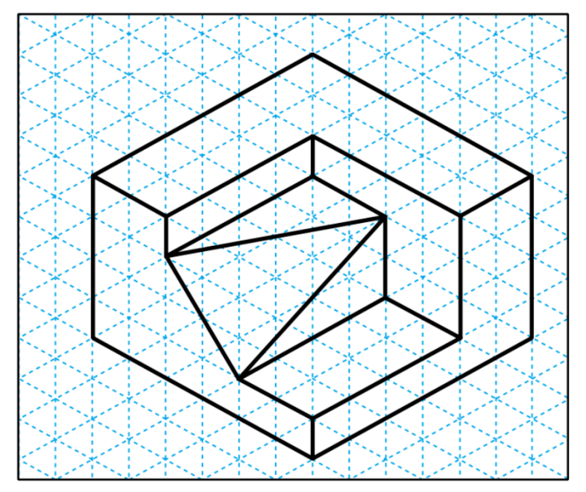

Figure 3

For figure 3, it is easy to select the front view along with top view and right side view, for only the marked three dimension has the least hidden line (none) as shown below.

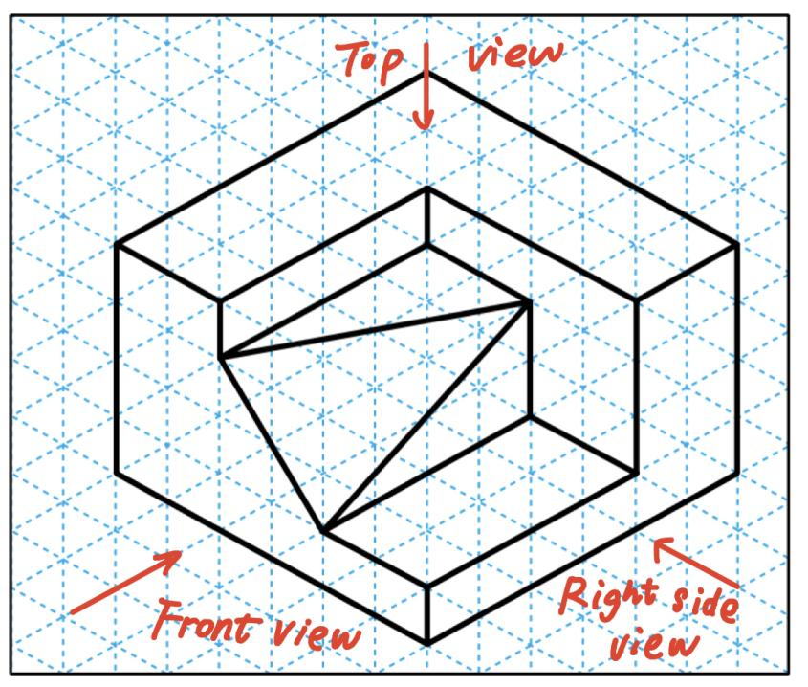

First, the front view is drawn based on the width, height and true length of the object. Next, according to the width and depth, draw the top view. Finally, following the height and depth, the right side view is drawn. During the drawing, construction lines are needed but in the final sketch, these lines should be removed.

The final sketch is shown below. The hand-drawn sketch is attached in the appendix at the end of the report.

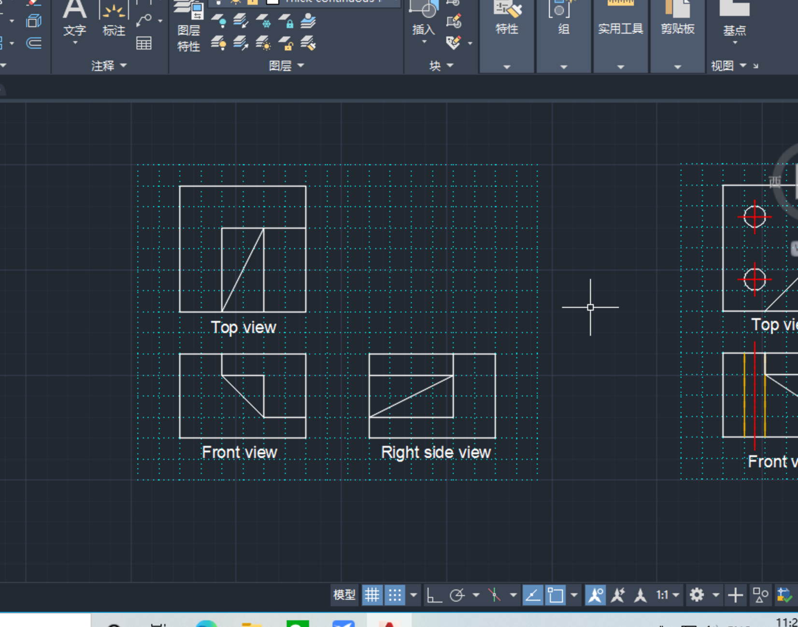

Final sketch for figure 3

2.1.2 “Figure 4”

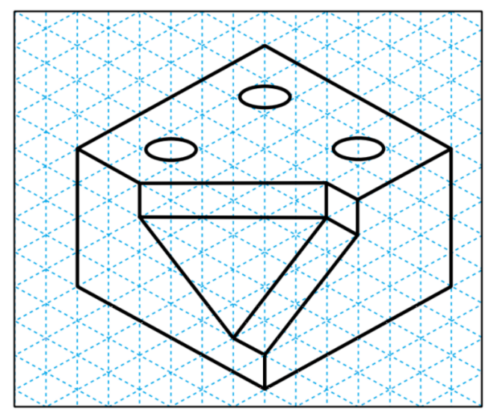

Figure 4

For figure 4, it is also easy to select the front view along with top view and right side view, for only the marked three dimension can represent the major features of the object as shown below.

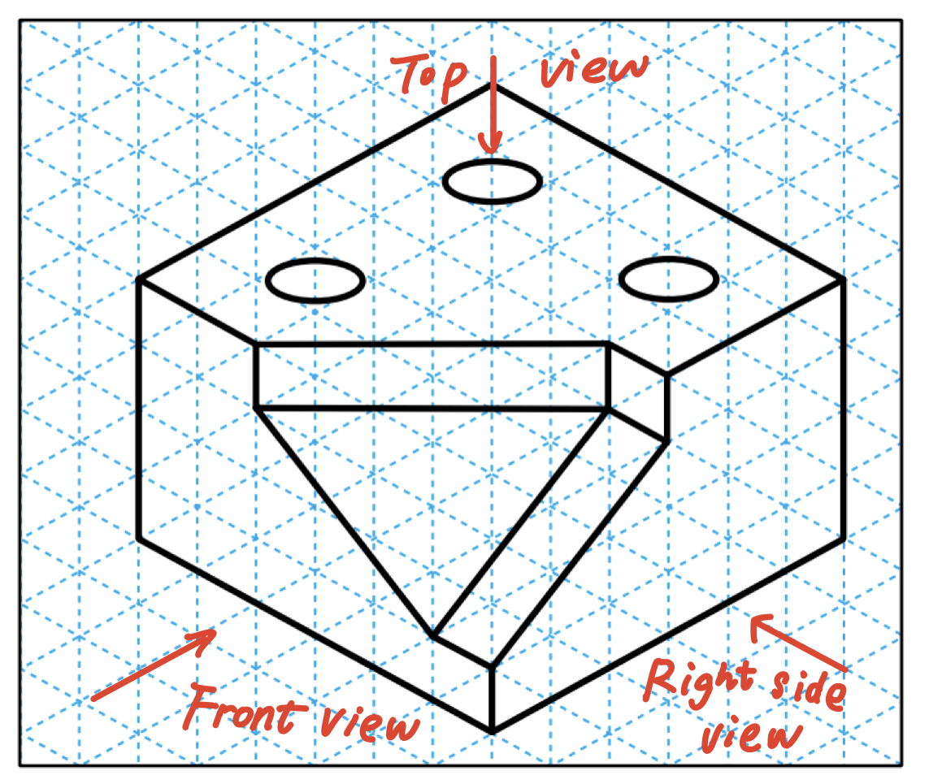

First, the front view is drawn based on the width, height and true length of the object. Next, according to the width and depth, draw the top view. Finally, following the height and depth, the right side view is drawn. During the drawing, construction lines are needed but in the final sketch, these lines should be removed.

The final sketch is shown below. The hand-drawn sketch is attached in the appendix at the end of the report.

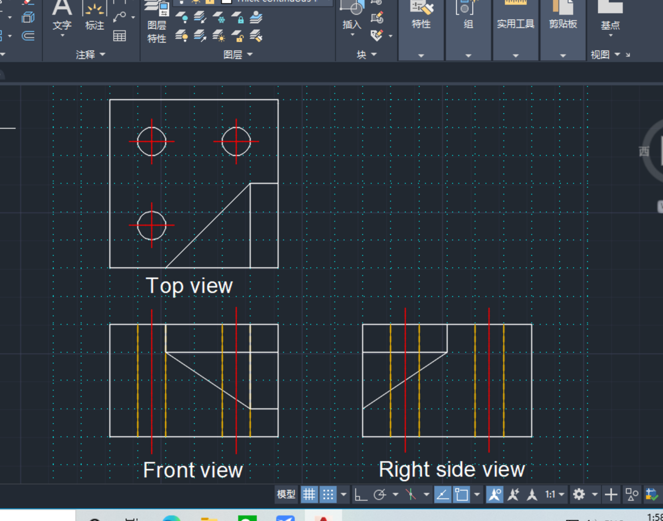

Final sketch for figure 4

**2.2 Isometric sketch**

The overall steps for isometric sketch is as follows. First, analyze the alignment of a given orthographic views. Secondly, select a suitable orientation of isometric axes. Third, interpret the lines/areas in orthographic views as a plane or surface. Finally, sketch that plane or surface in an isometric axes.

Then for this specific project, which is a missing view problem, the solution steps should be:

1. Analyze the alignment of a given orthographic views and a missing view.
2. Incrementally and iteratively sketch a pictorial view of a possible object.
3. Sketch the missing view from a possible object.

2.2.1 “Figure 5”

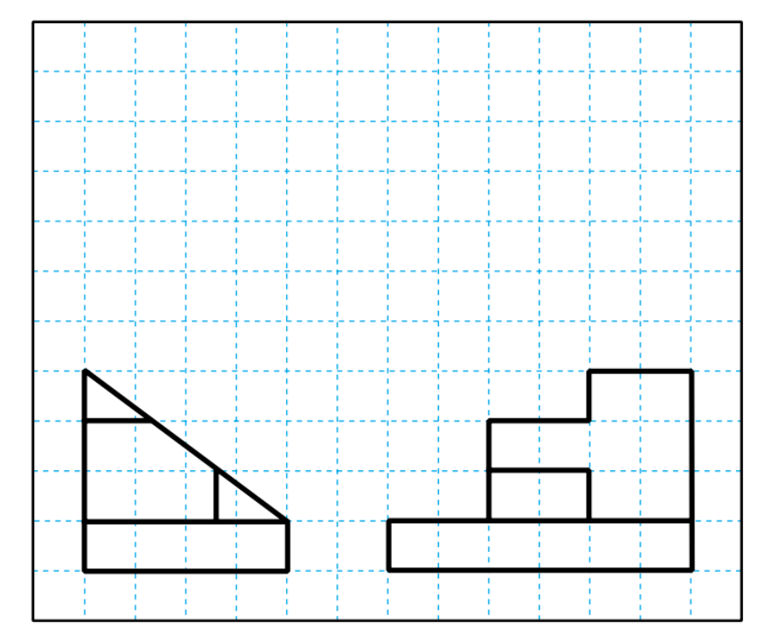

Figure 5

First, it is easy to find out that these two given views are front view and right side view, and the missing view is top view.

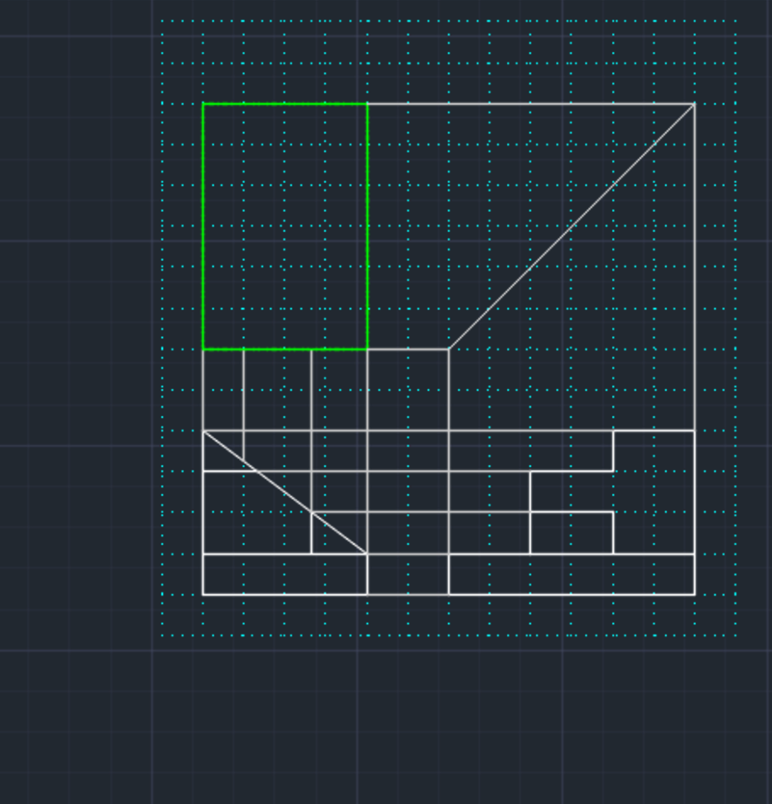

And then sketch the isometric sketch by using the above solution steps.

The isometric sketch is as follows.

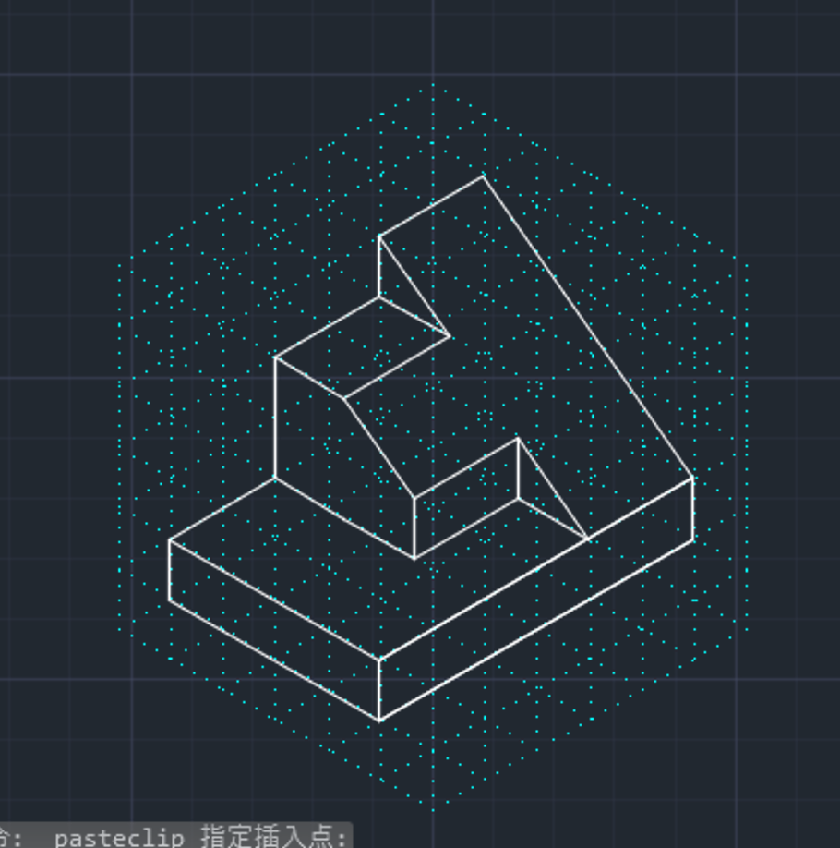

Isometric sketch for figure 5

After drawing the isometric sketch, the missing view (Top view) can be easily drawn by using the method of 2.1.

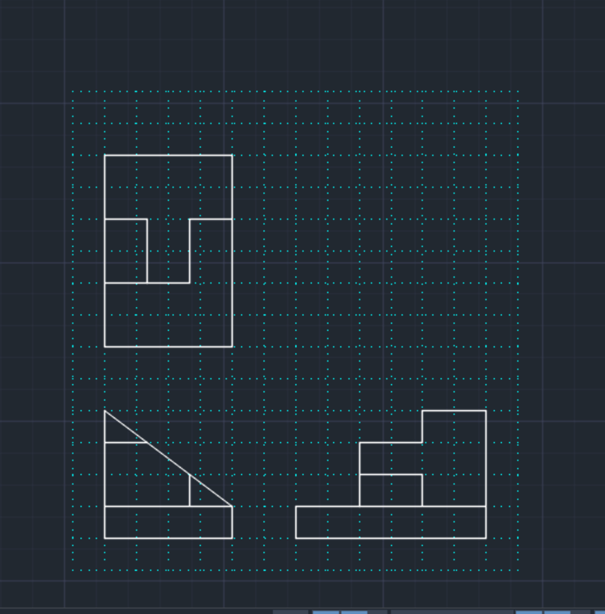

Missing view for figure 5

2.2.2 “Figure 6”

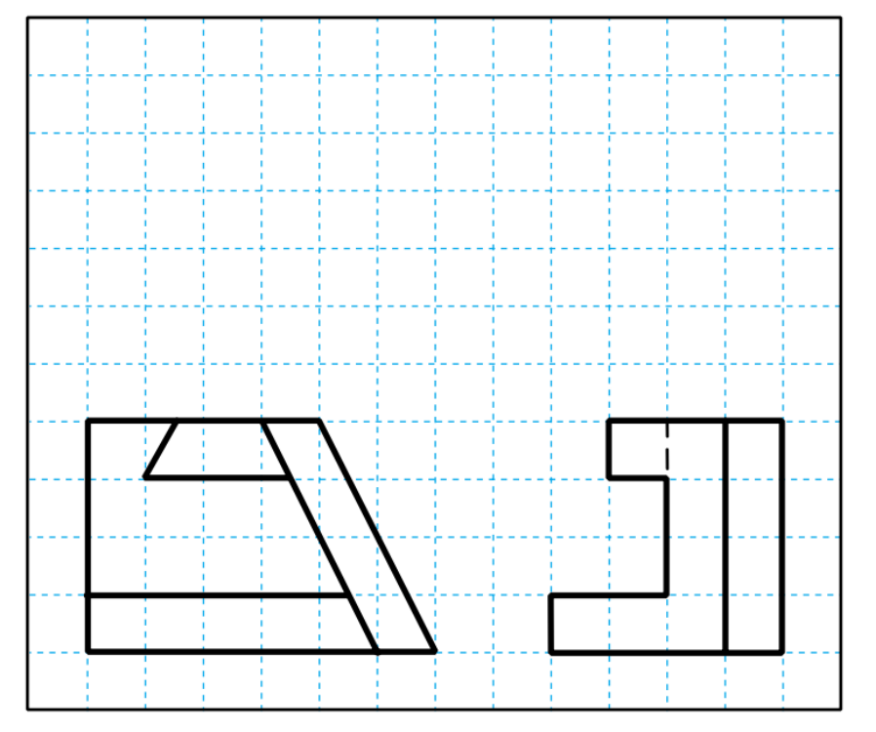

Figure 6

First, it is easy to find out that these two given views are front view and right side view, and the missing view is top view.

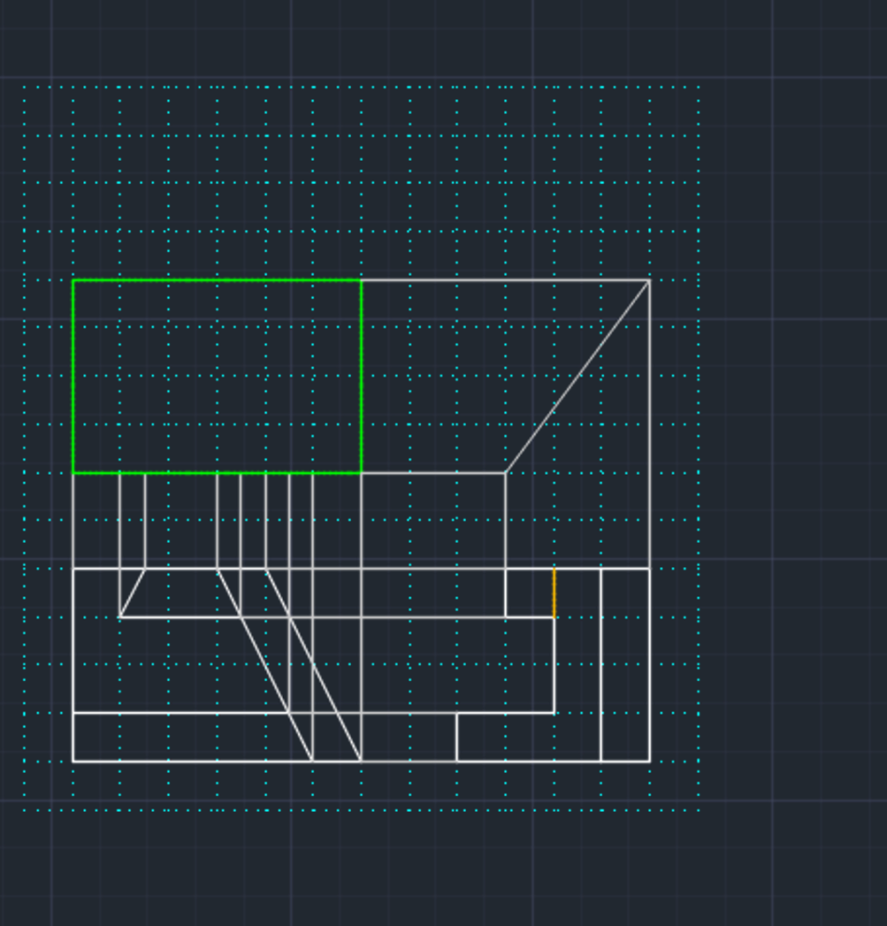

And then sketch the isometric sketch by using the above solution steps.

The isometric sketch is as follows.

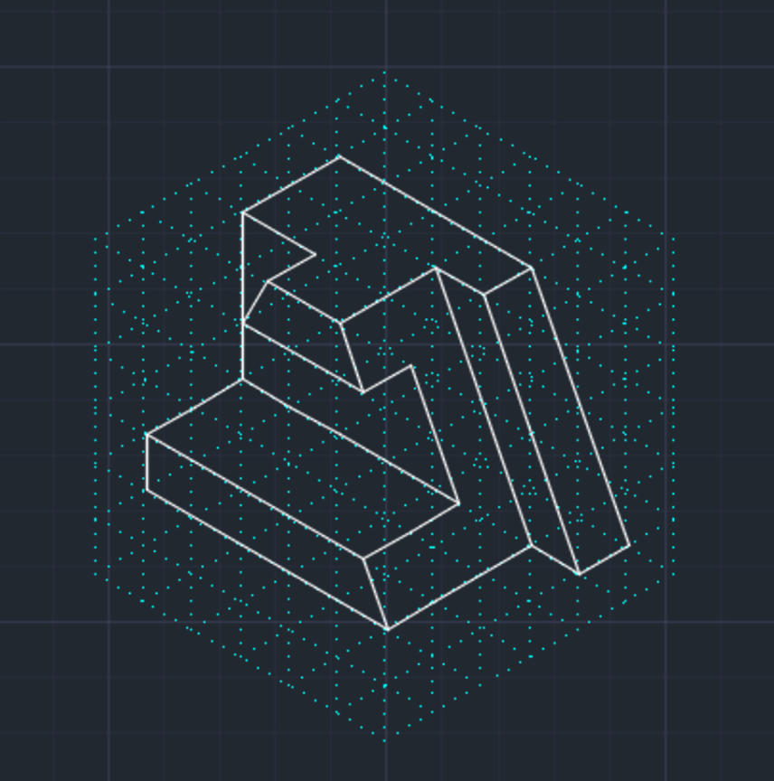

Isometric sketch for figure 6

After drawing the isometric sketch, the missing view (Top view) can be easily drawn by using the method of 2.1.

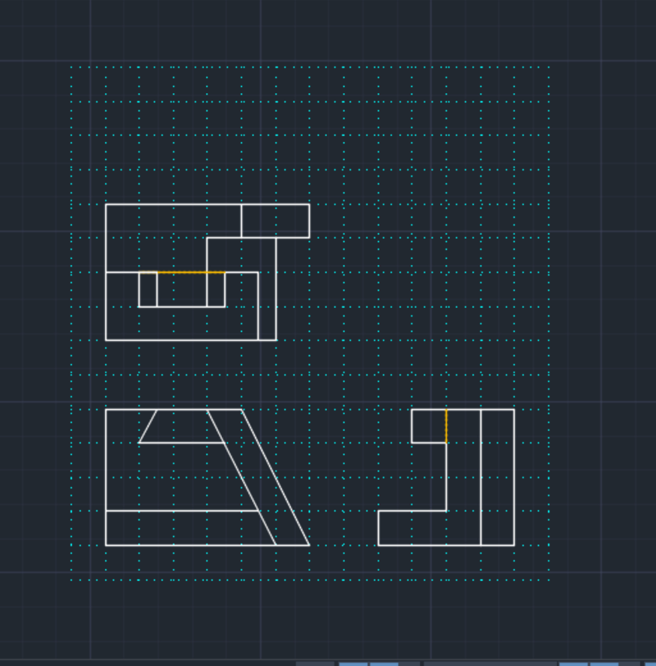

Missing view for figure 6

**2.3 Computer Aided Drafting (CAD)**

CAD is the English abbreviation of Computer Aided Design. It is currently a popular auxiliary drawing software system in China, which is widely used in civil construction, decoration, urban planning, garden design, electronic circuit, mechanical design, clothing, shoes and hats, aerospace, light industry, chemical industry and many other fields.

CAD drawing has the advantages of accuracy, quickness, convenient modification, and convenient storage, as well as powerful 3D modeling capabilities. It can help design and store traditional drawings.

There are many CAD software in the professional field, such as AutoCAD, Solidworks, Alibra and so on.

CAD is a very important tool for engineers and should be learned deeply.

### CAD Modeling/Design

In this section, the isometric sketch in Figure 5 and 6 will be given and 5 angles capture these two objects.

**3.1 Figure 5**

Isometric sketch for figure 5:

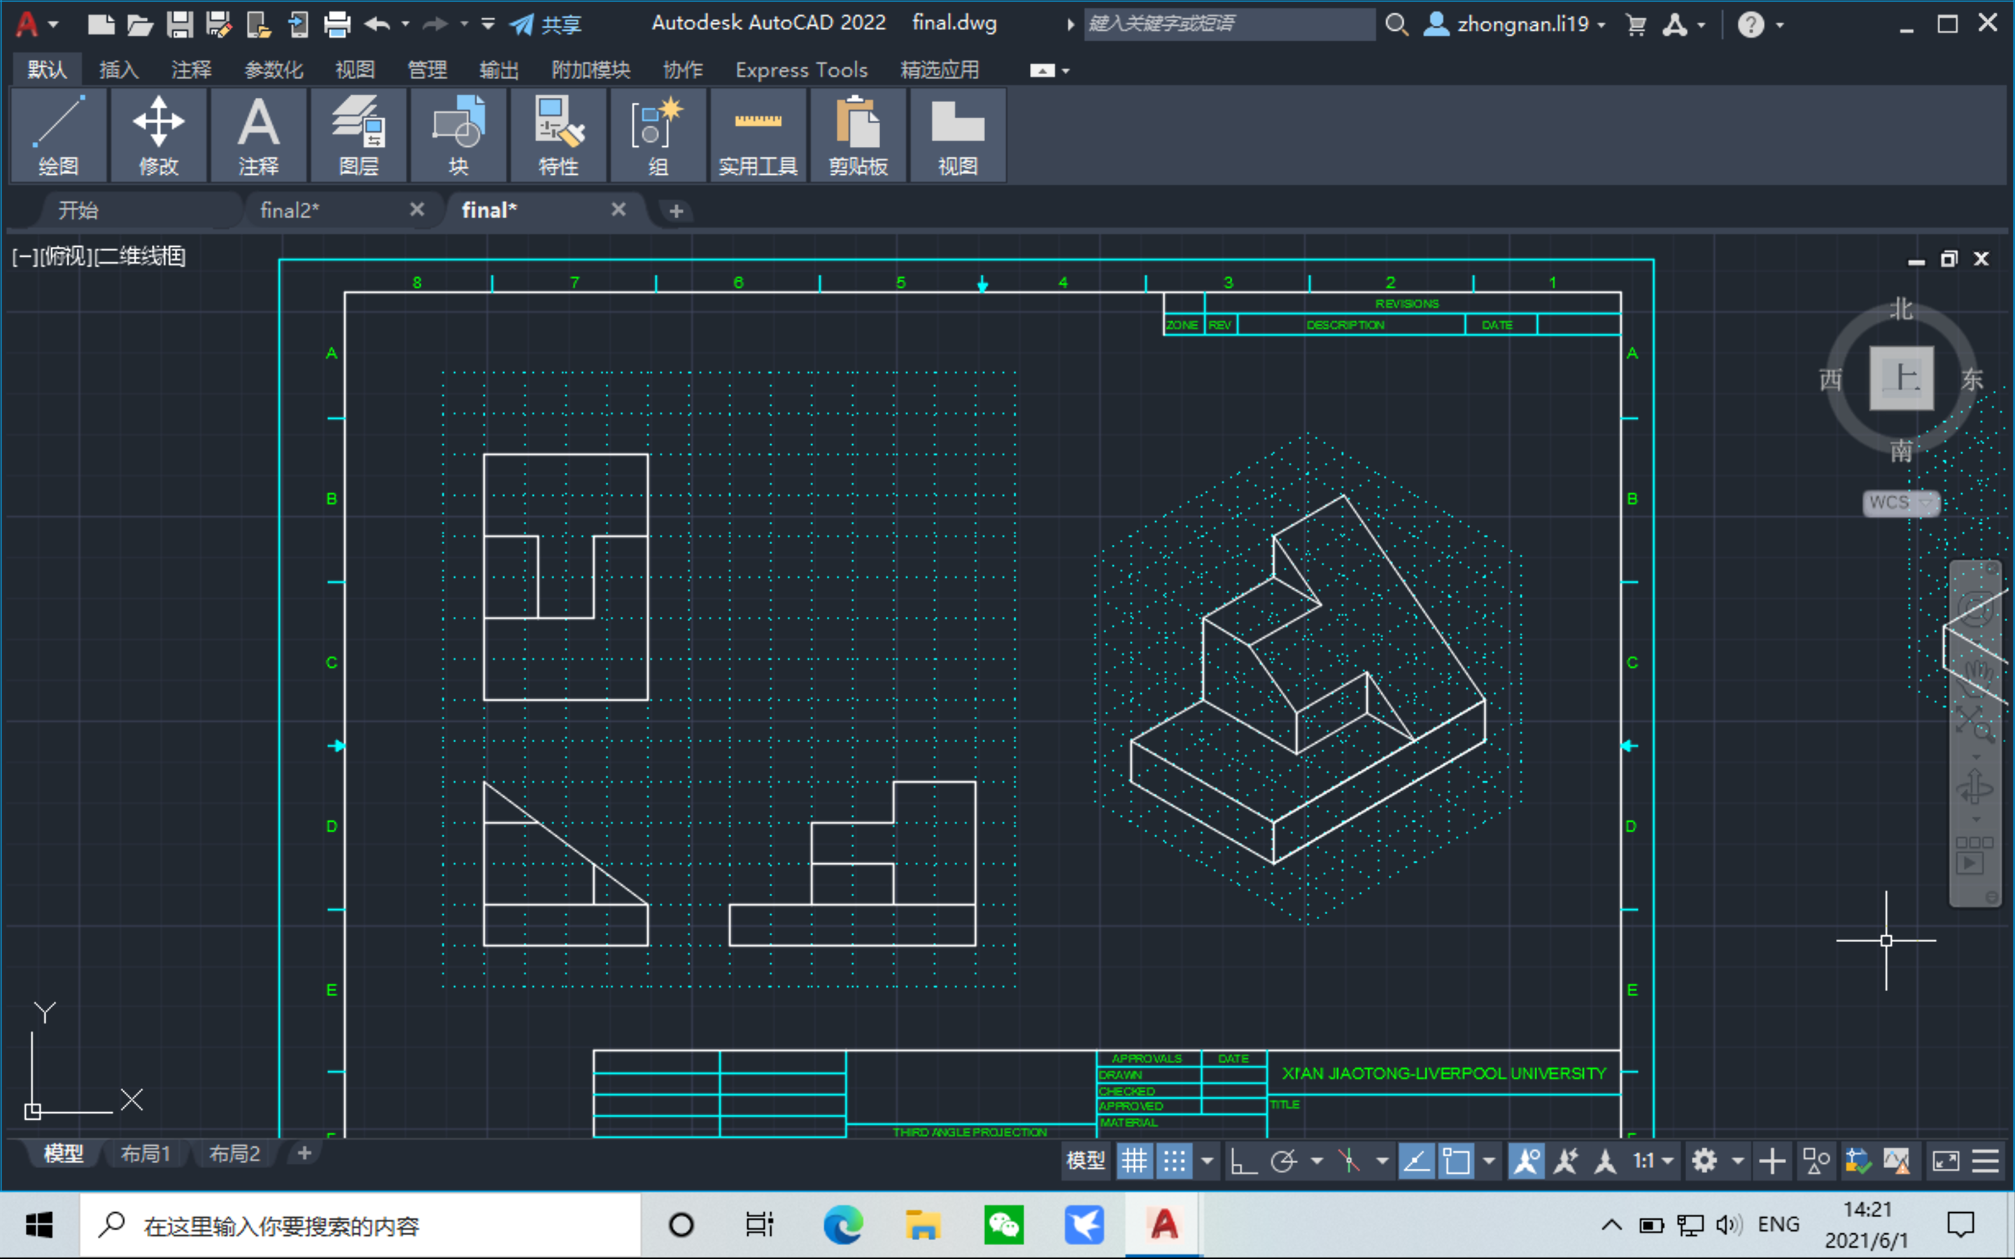

5 various angles capture for figure 5:

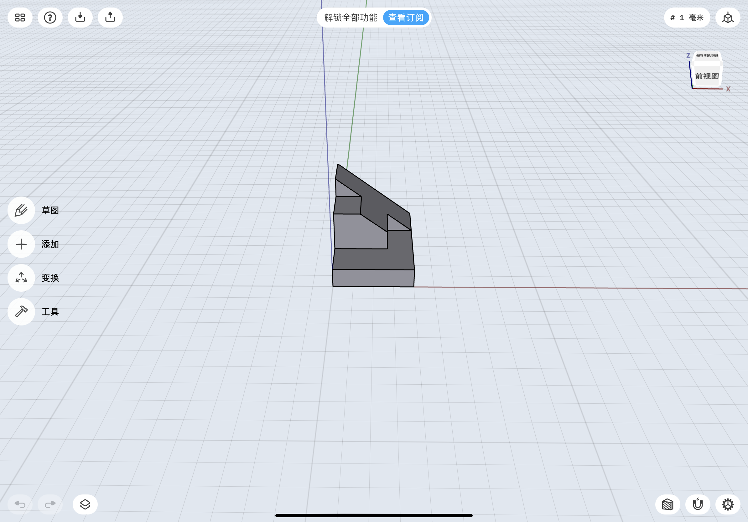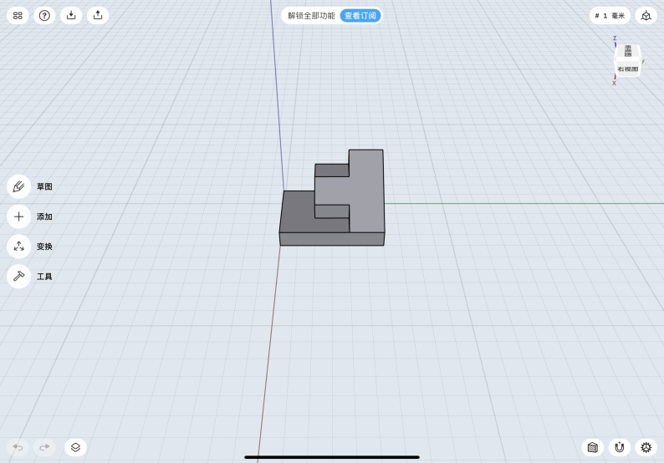

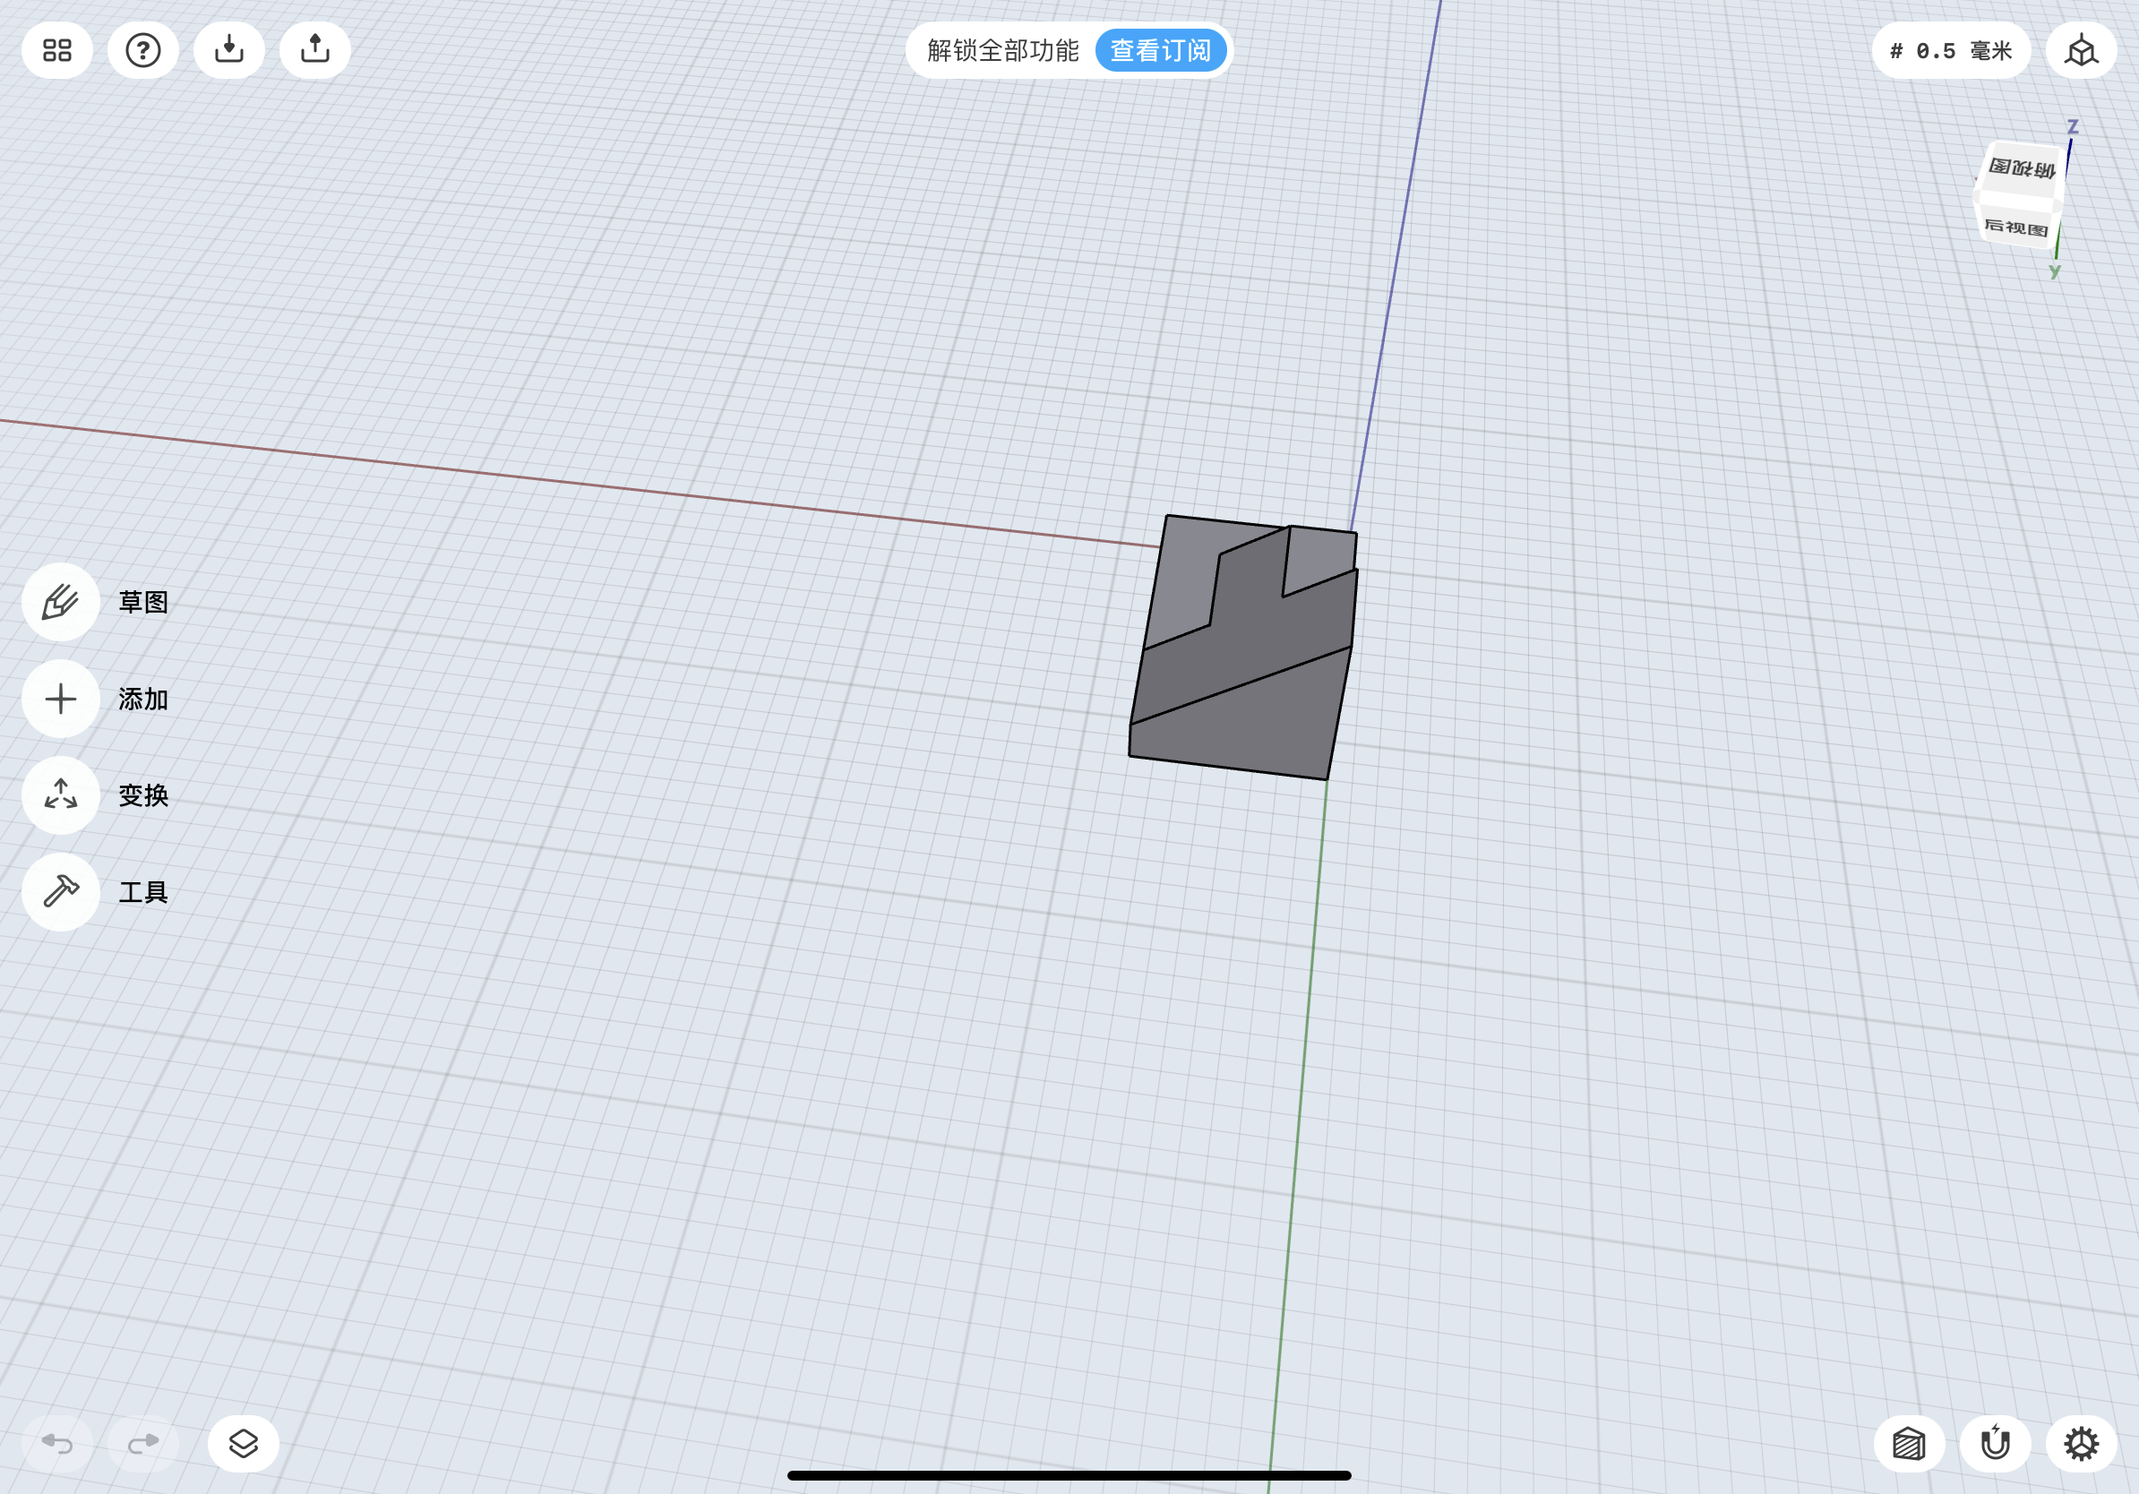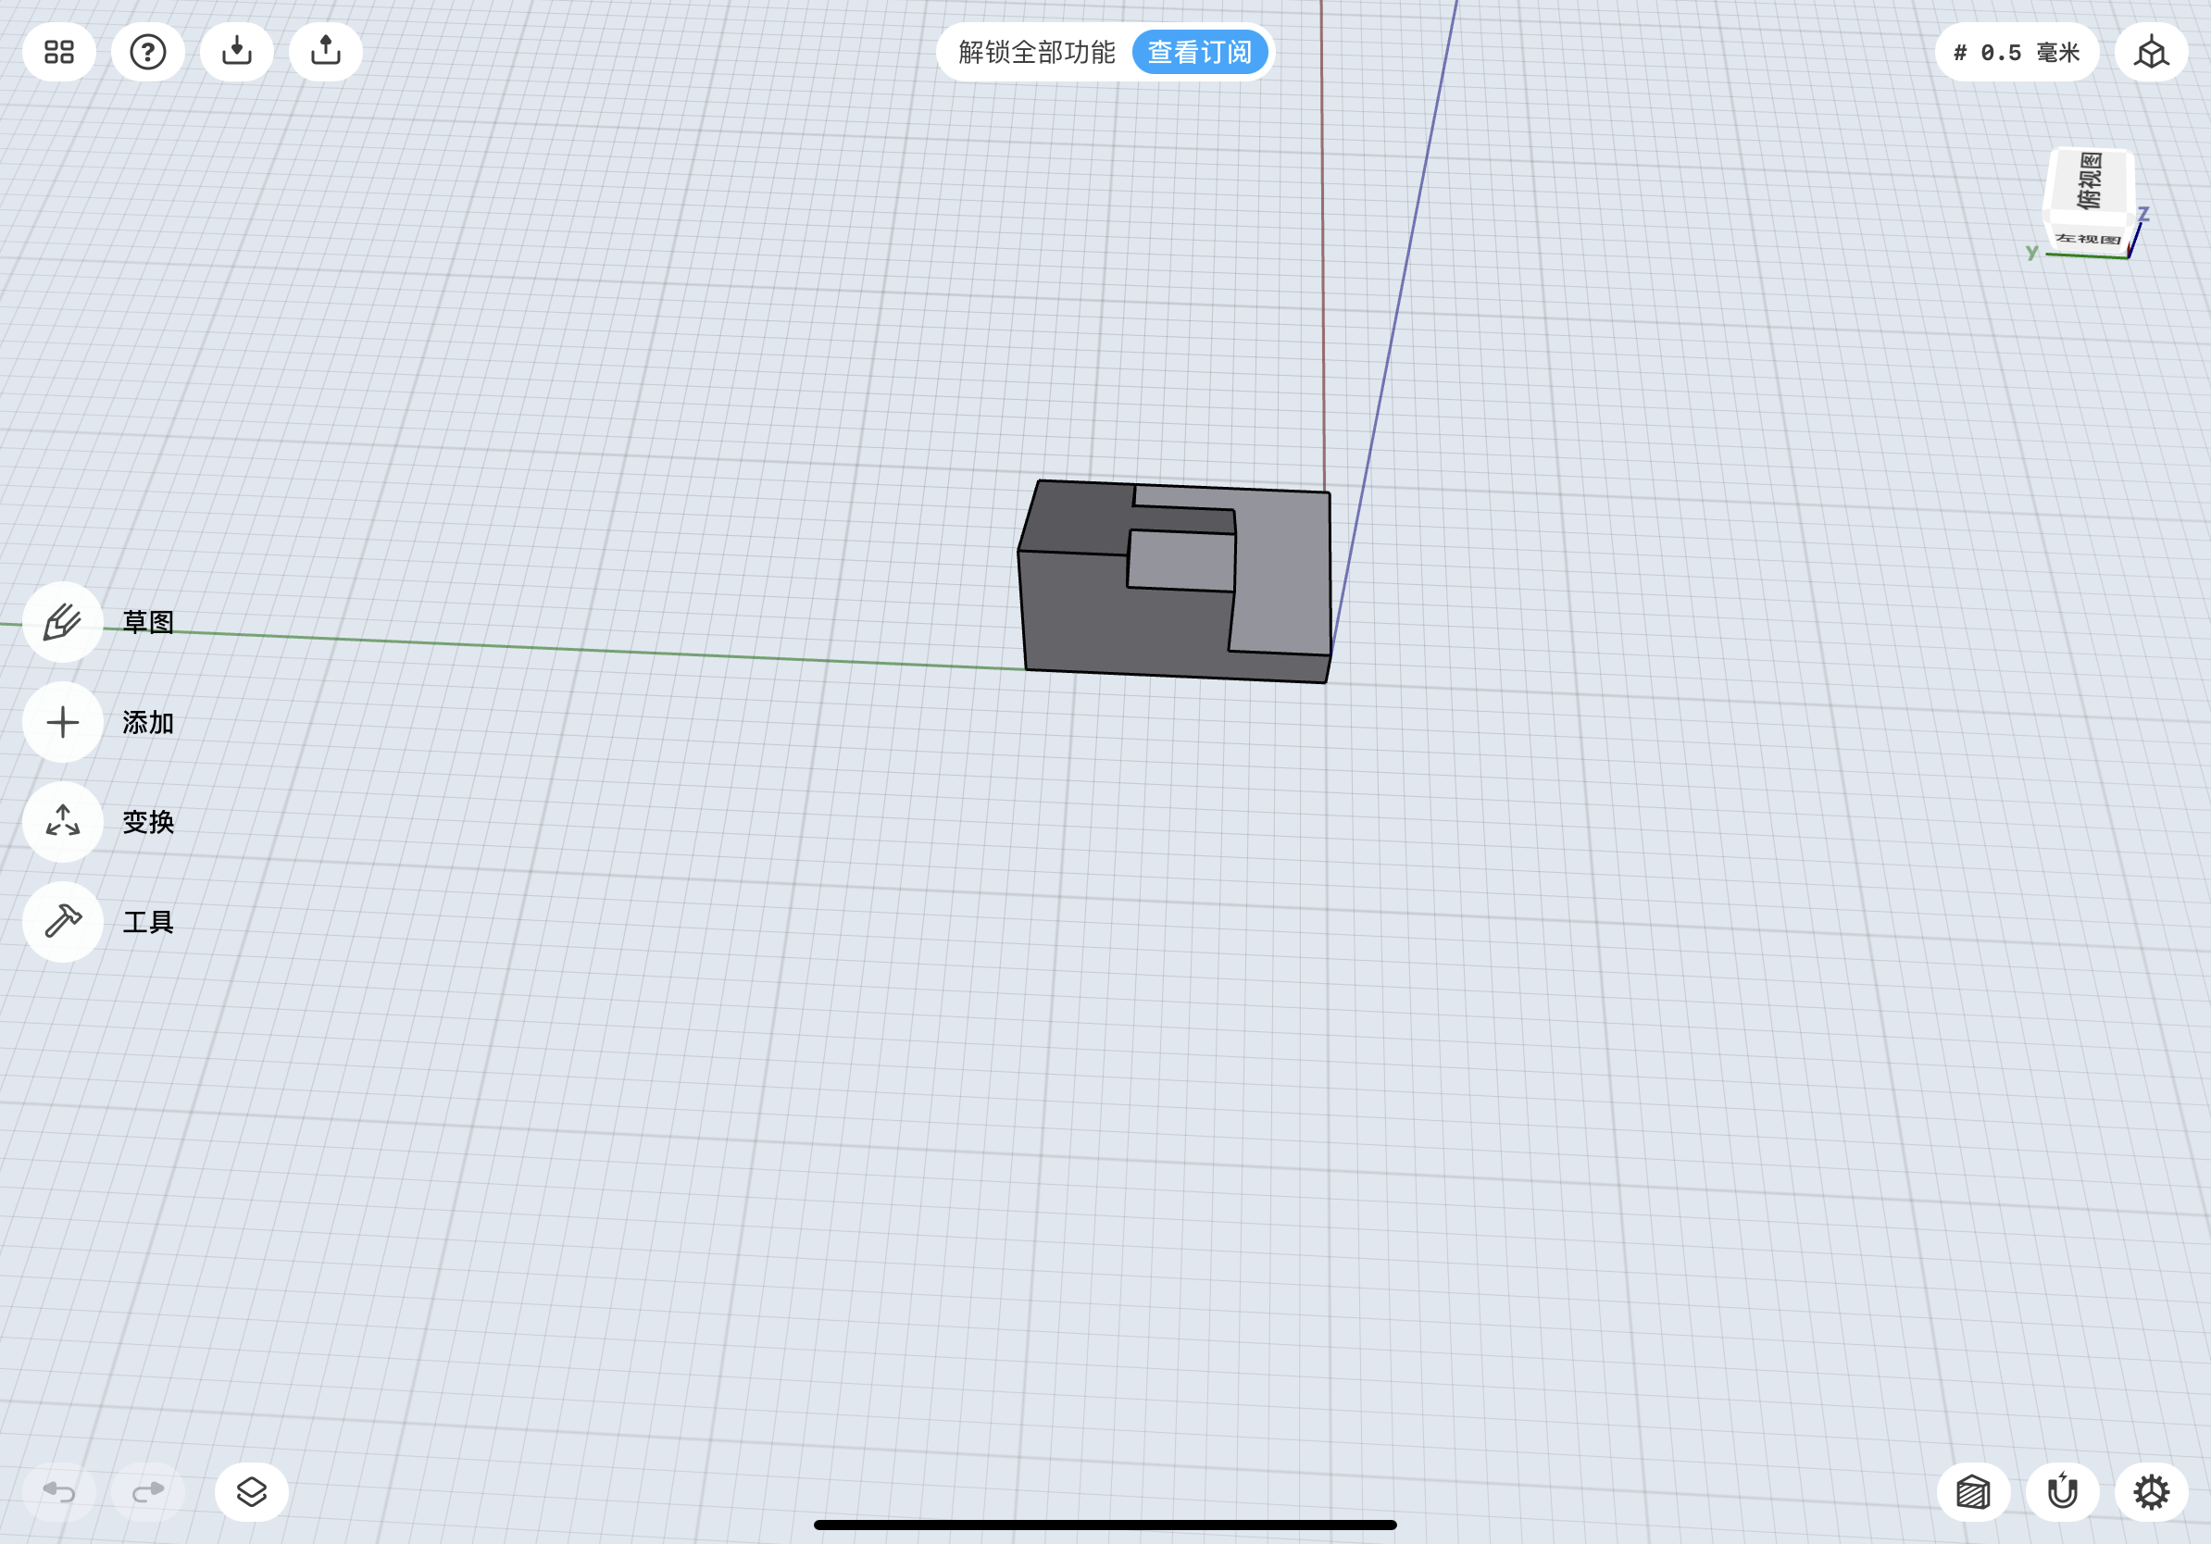

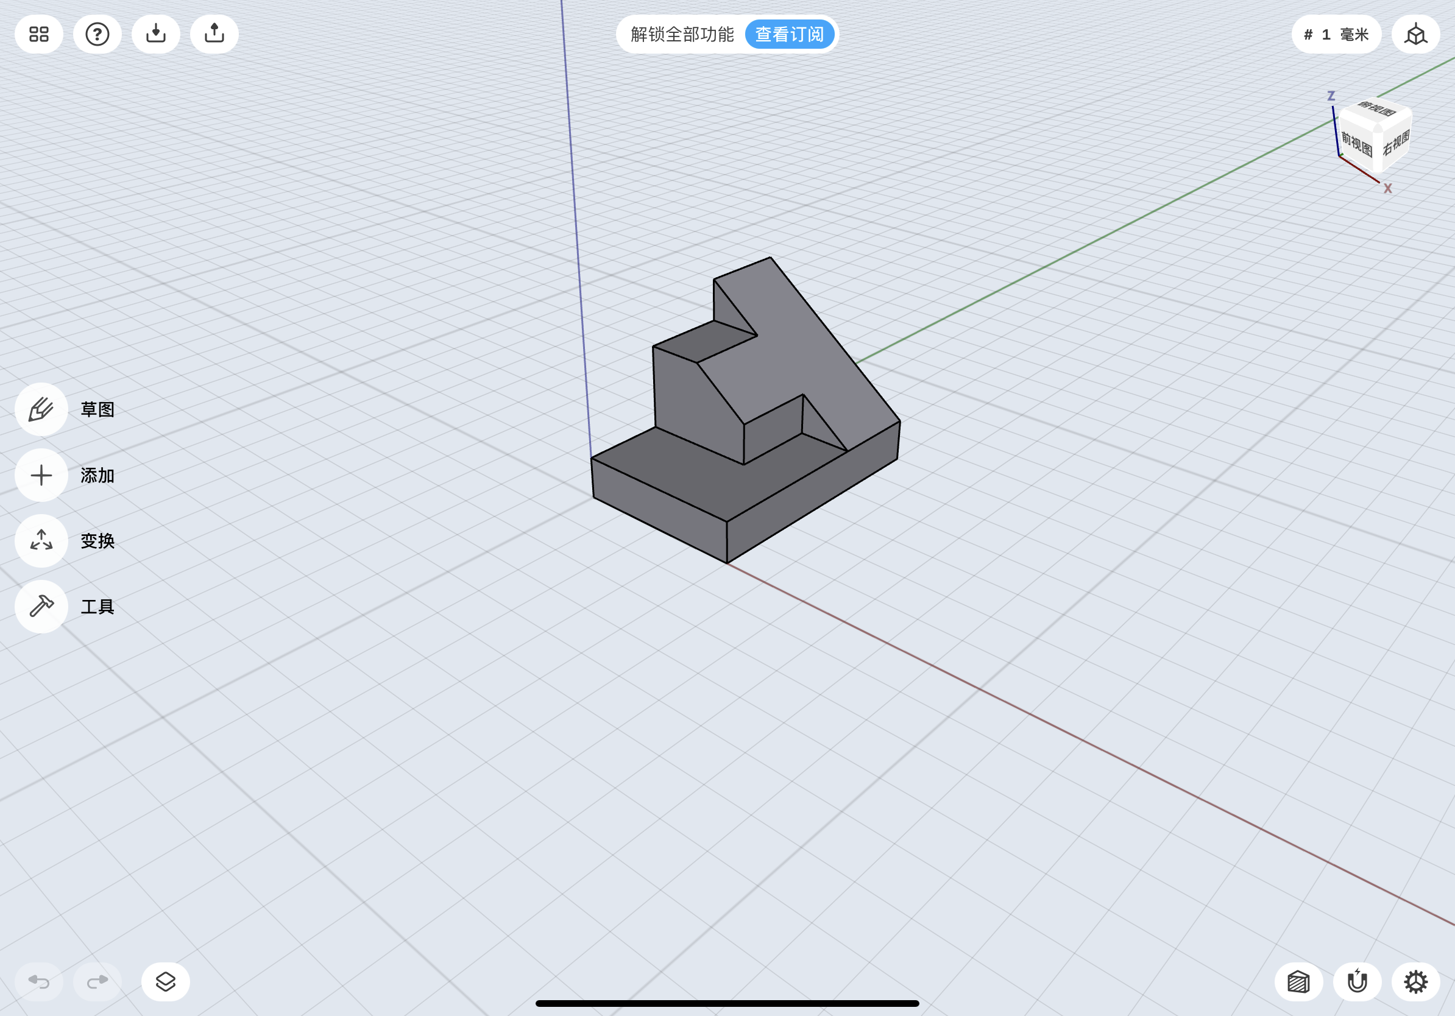

**3.2 Figure 6**

Isometric sketch for figure 6:

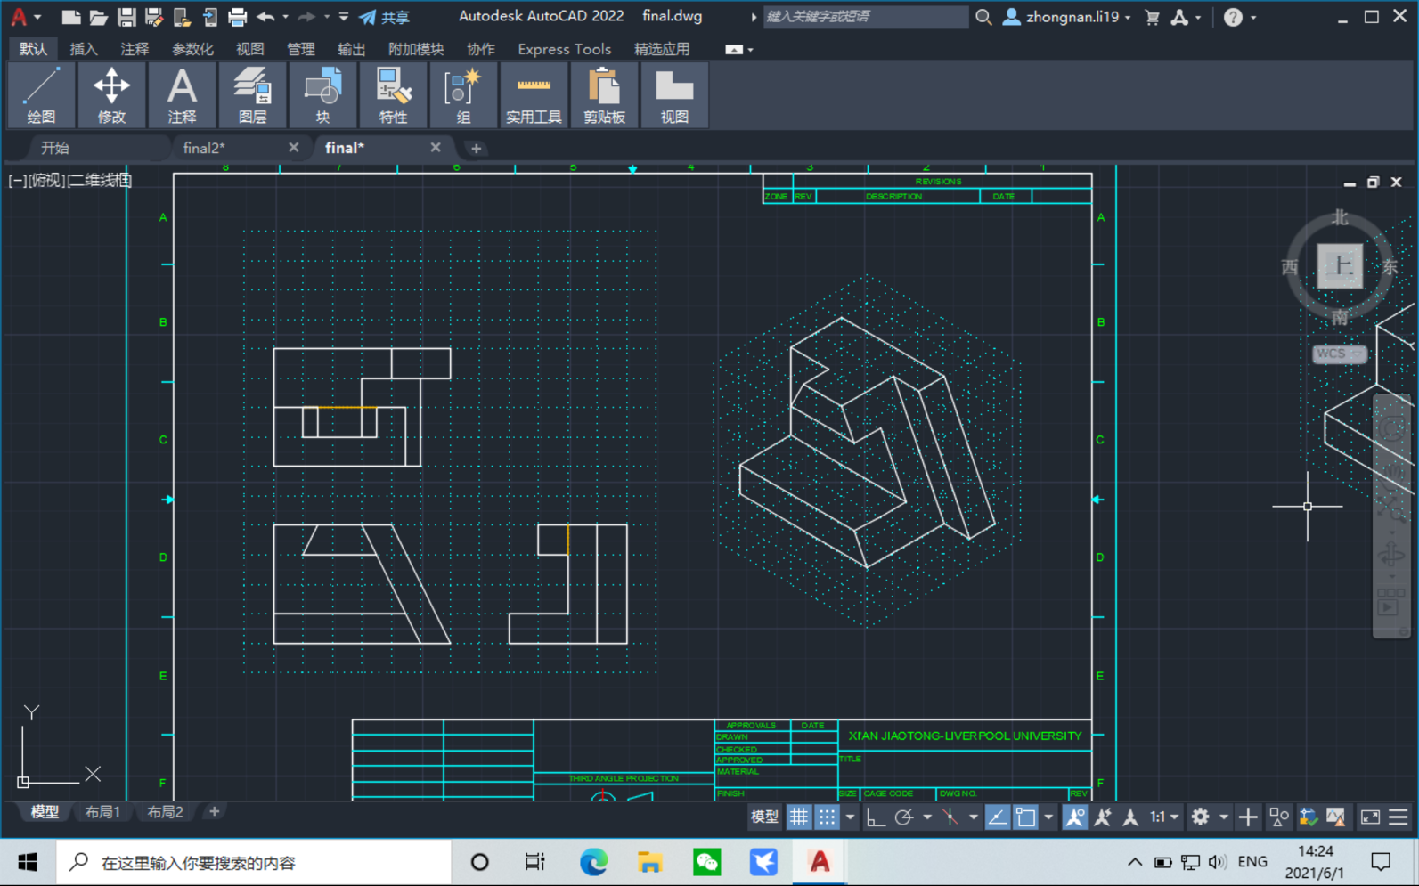

5 various angles capture for figure 6:

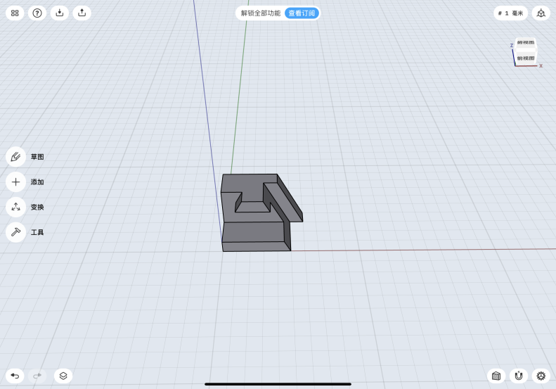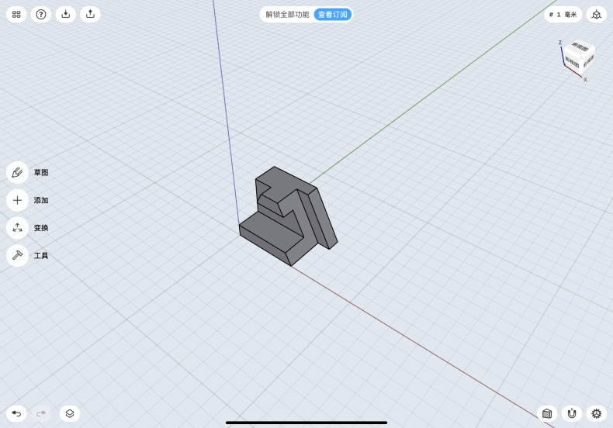

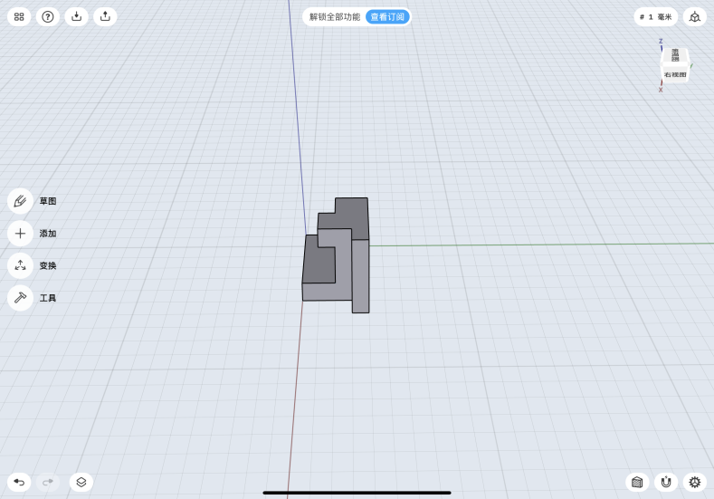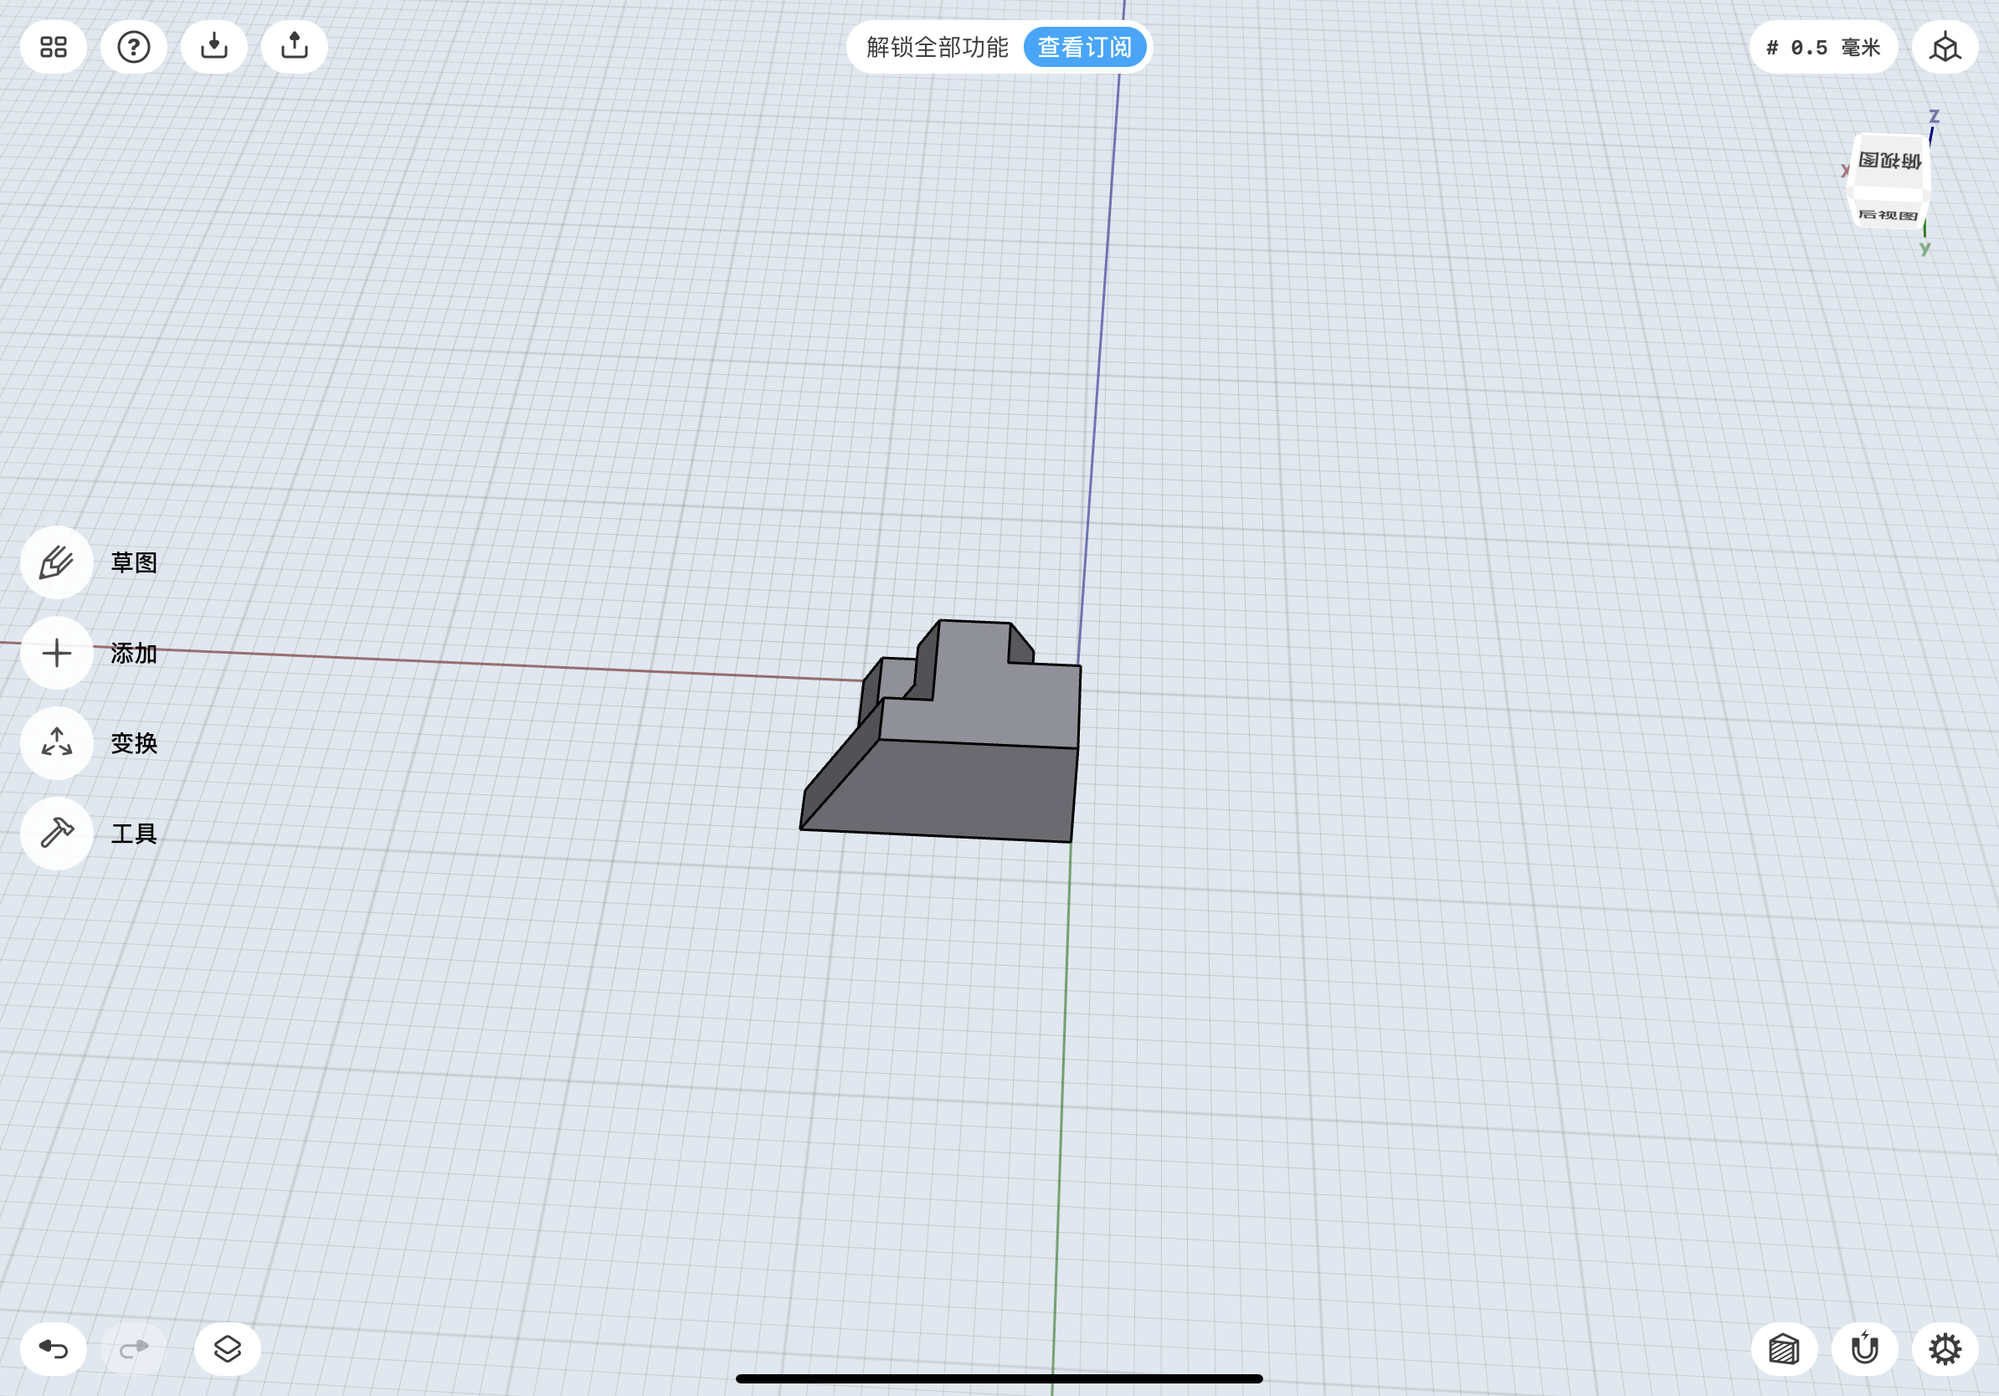

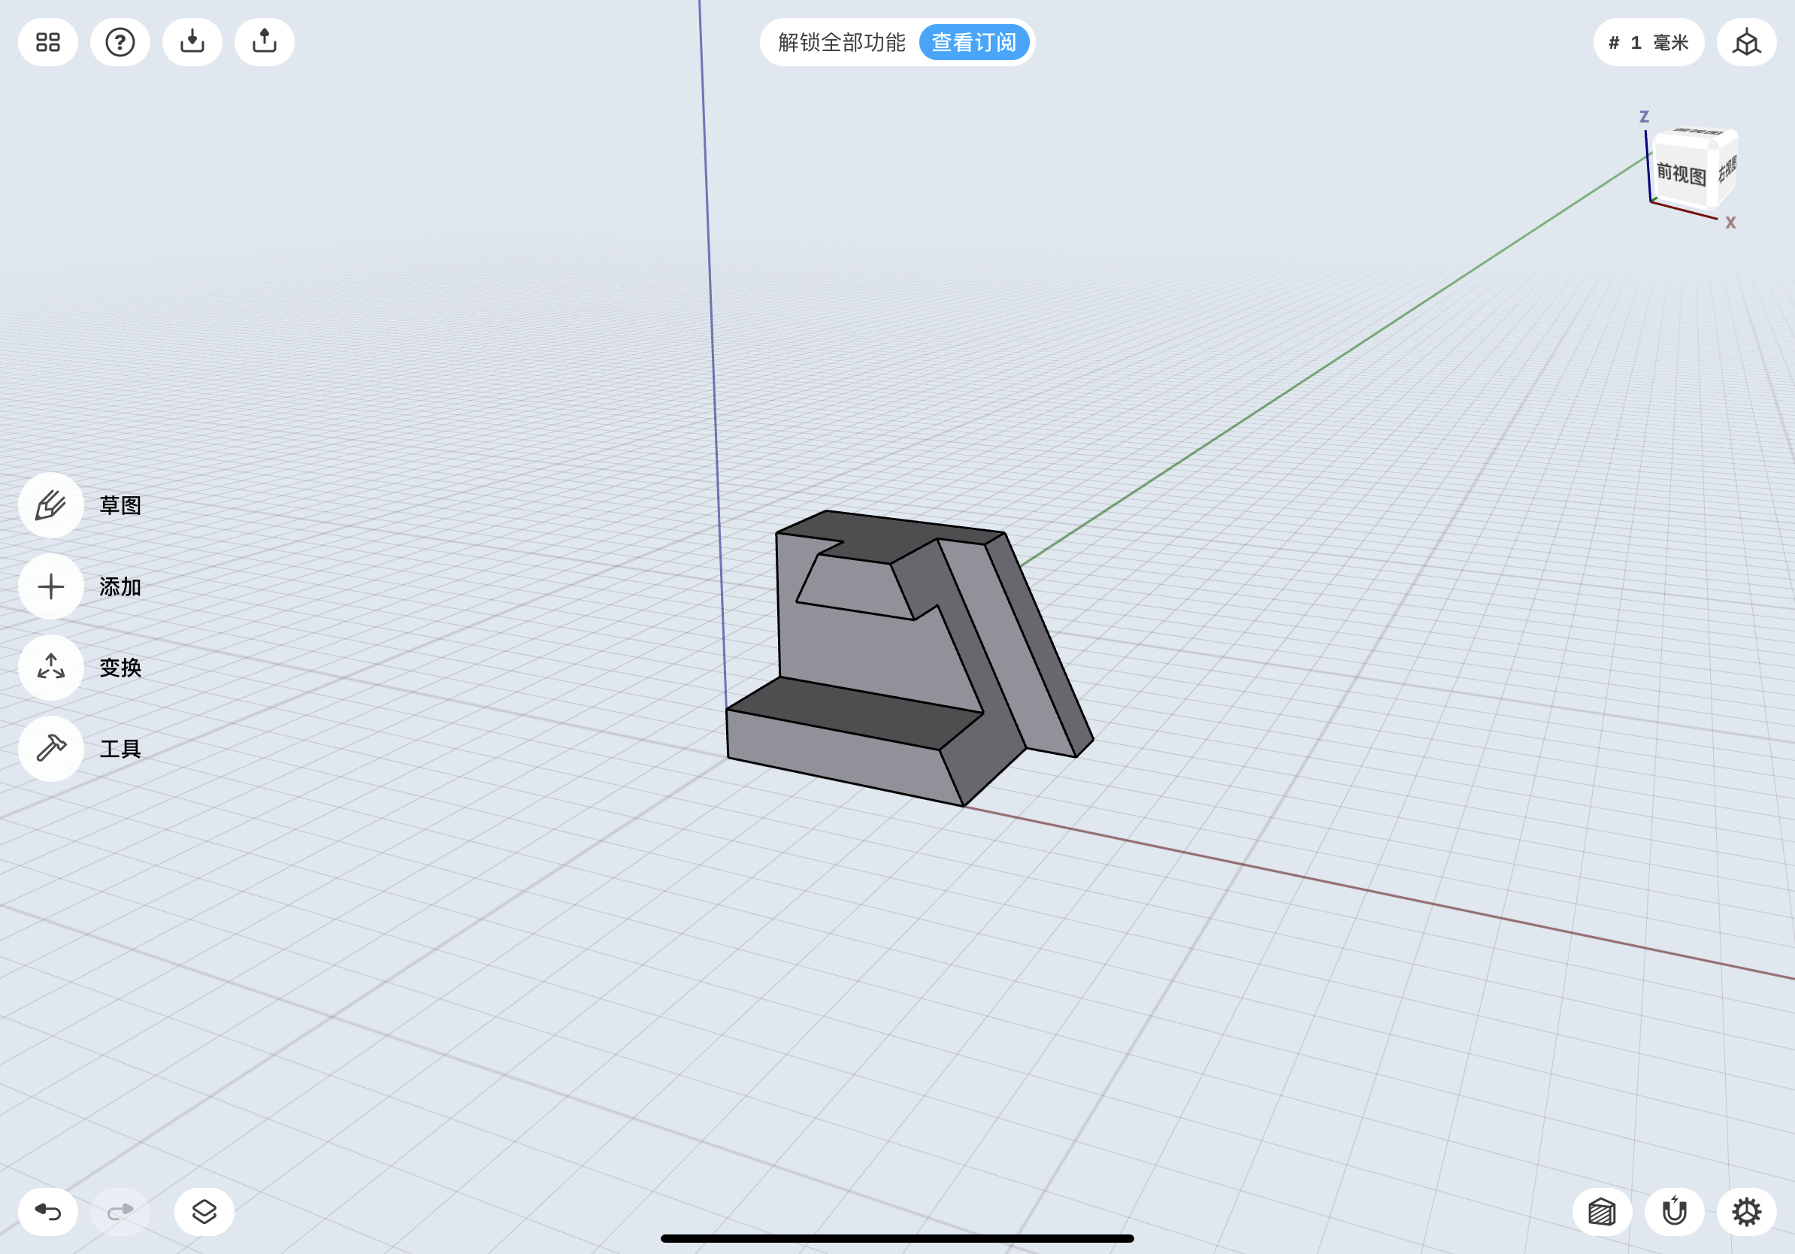

1. **Conclusion**

In conclusion, some benefits of multiview drawing, along with the benefits of isometric sketch were covered in the introduction part. In the main body, orthographic drawing steps for two given objects and isometric sketch steps the object were given. Also, the Computer Aided Drafting (CAD) application was discussed. Finally, CAD modelings and designs were provided at the end of the report. The hand-drawn scans will be given in the appendix.

During the project, I demonstrated a clear understanding of the standards in engineering drawing. Also, orthographic projection is applied to view and analyze engineering solids. Moreover, I proposed the isometric representation of engineering components. I gained a lot from the final project and expect to use the knowledge in the future studying and working.

**Appendix**

Hand drawing for figure 3:

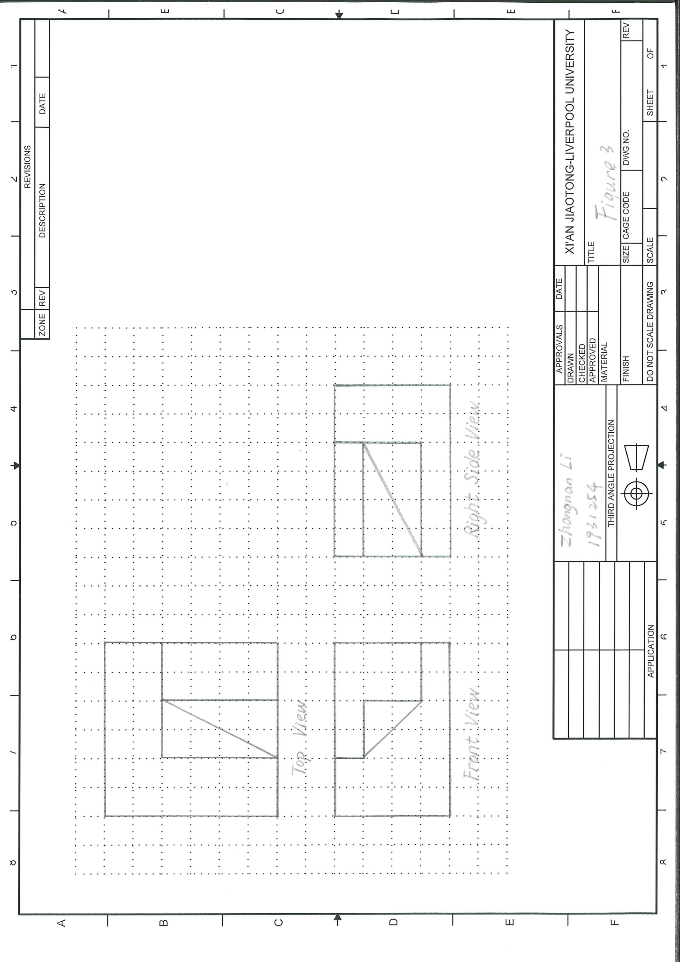

Hand drawing for figure 4:

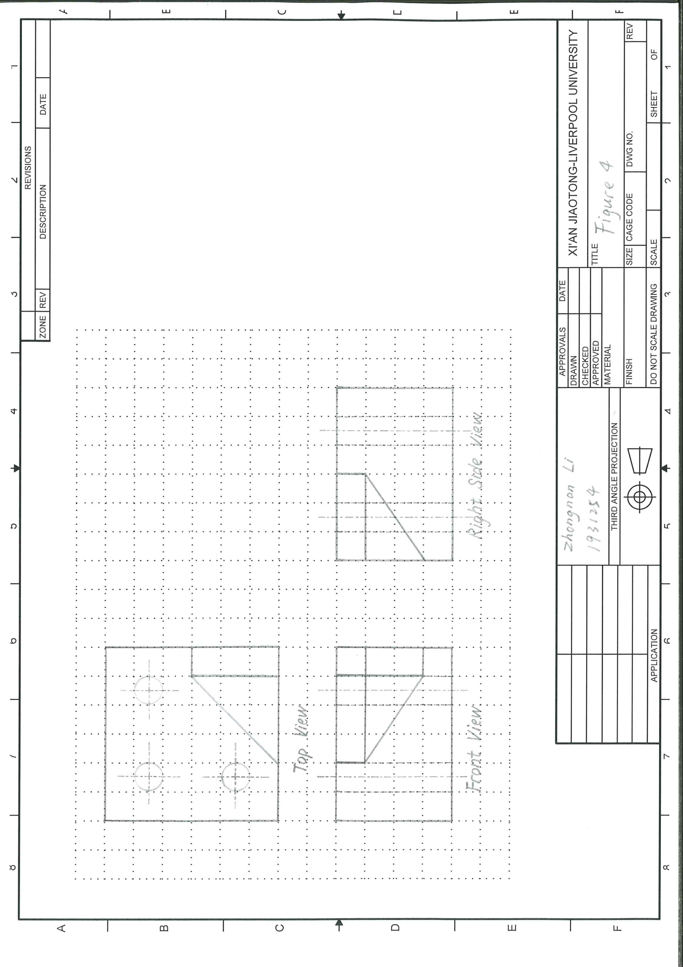

Hand drawing for figure 5:

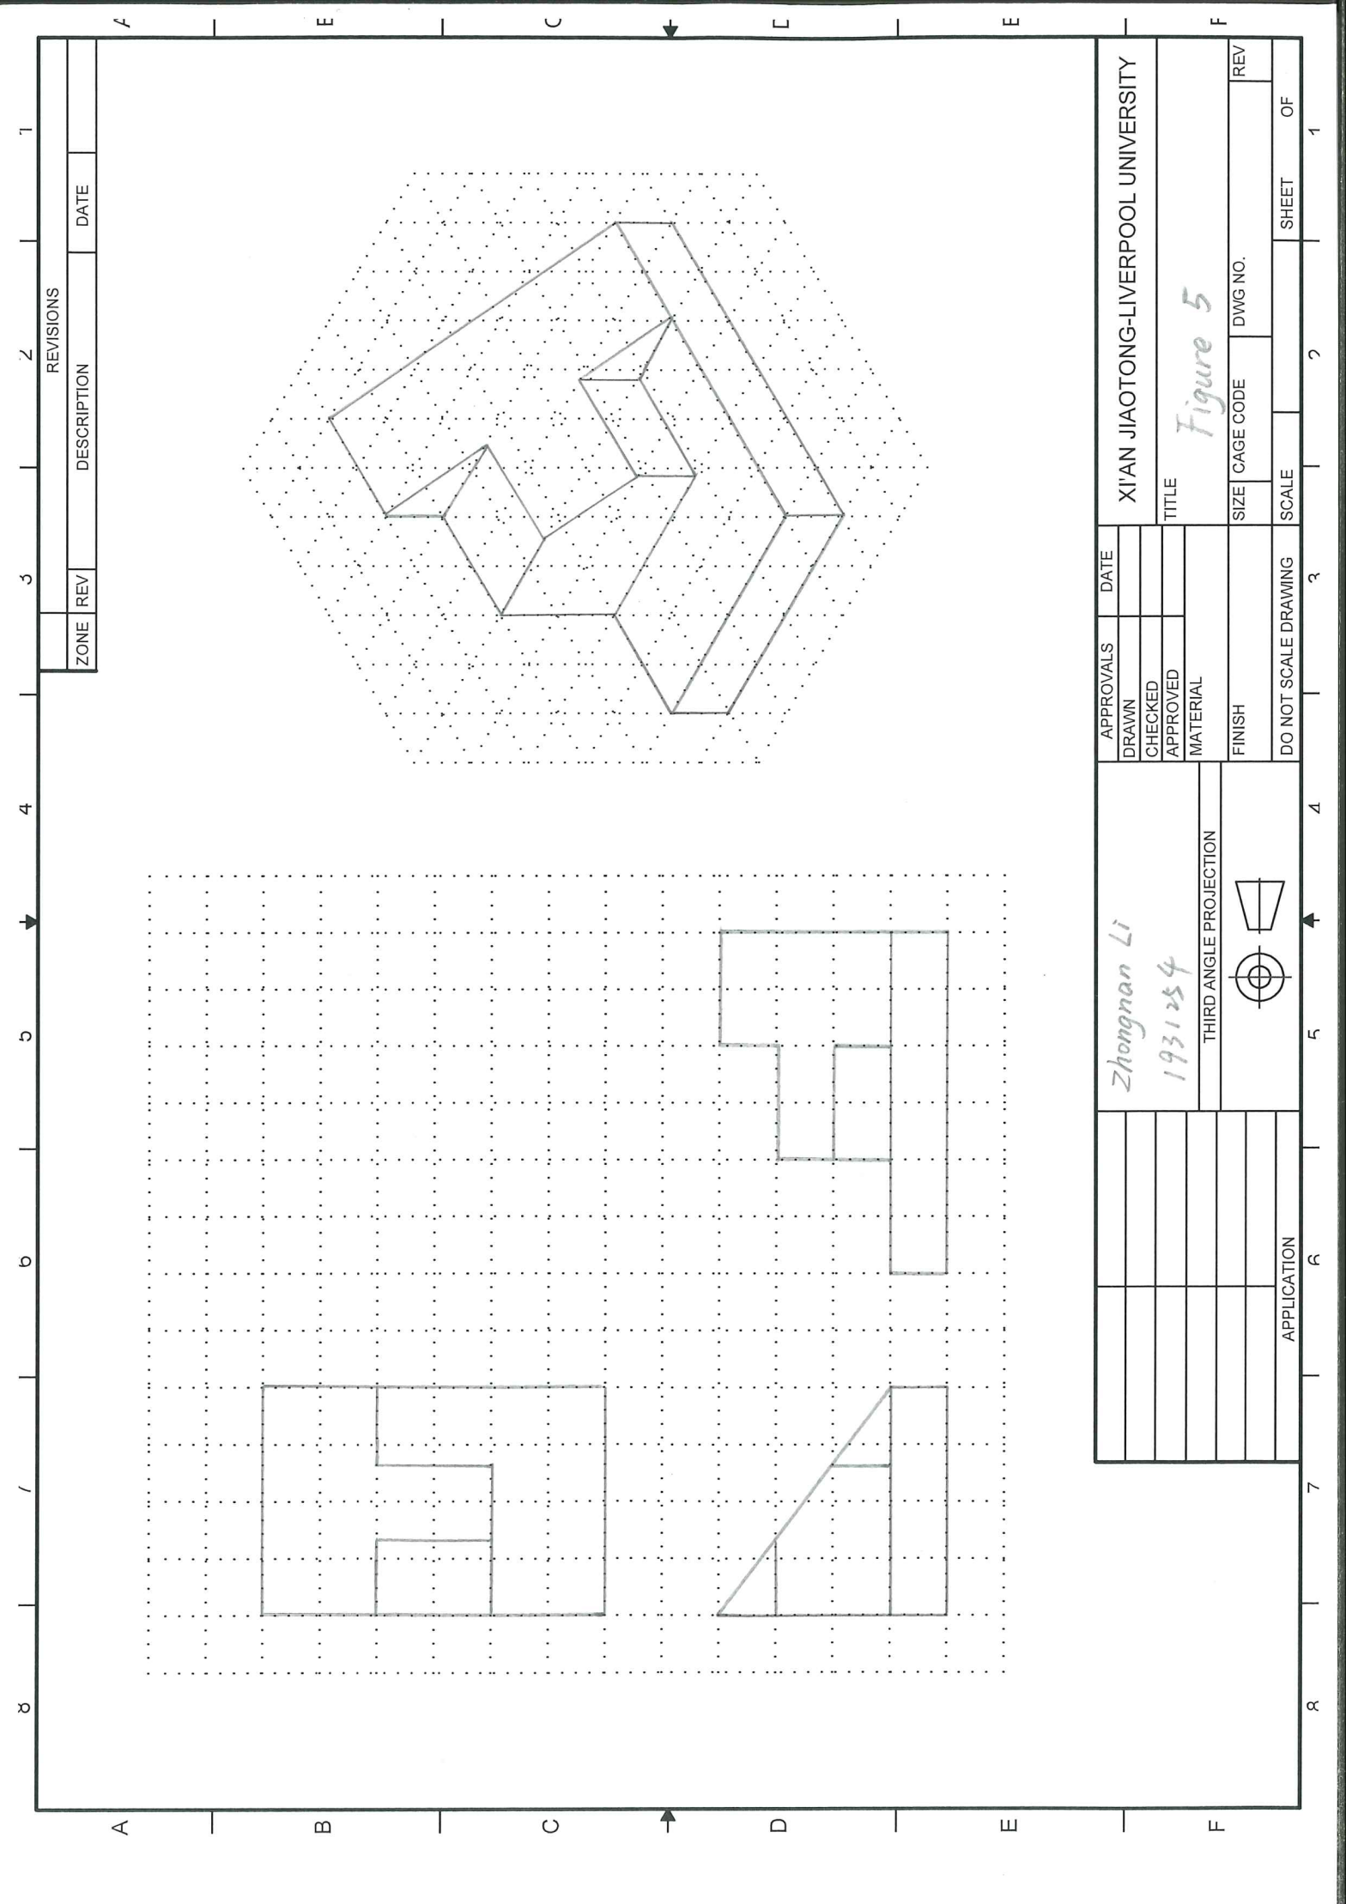

Hand drawing for figure 6:

